# IoT Based Smart Water Quality Monitoring System

Sujit Kumar1, Alka Raj2, Md Zafar3, Hrithik Raushan4, Adarsh Kumar5

*1Department of Electrical Engineering, Government Engineering College, Banka, Bihar 813102*

*2Department of Computer Science Engineering, Government Engineering College, Banka, Bihar 813102, India*

*3Department of Electrical Engineering, Government Engineering College, Banka, Bihar 813102, India*

*4Department of Computer Science Engineering, Government Engineering College, Banka, Bihar 813102, India 5Department of Computer Science Engineering, Government Engineering College, Banka, Bihar 813102, India*

***Abstract: This study addresses a critical issue in pollution of water is one of the main threats in recent times as drinking water is getting contaminated and polluted. The polluted water can cause various diseases to humans and animals, which in turn affects the life cycle of the ecosystem. If water pollution is detected in an early stage, suitable measures can be taken and critical situations can be avoided. To make certain the supply of pure water, the quality of the water should be examined in real-time. Smart solutions for monitoring of water pollution are getting more and more significant these days with innovation in sensors, communication, and Internet of Things (IoT) technology. In this paper, a detailed review of the latest works that were implemented in the arena of smart water pollution monitoring systems is presented. The paper proposes a cost effective and efficient IoT based smart water quality monitoring system which monitors the quality parameters uninterruptedly. The developed model is tested with three water samples and the parameters are transmitted to the cloud server for further action.***

***Keywords: Node MCU, MQTT Cloud Server, Turbidity Sensor, Water Quality, Water sample***

1. **INTRODUCTION**

***Water pollution ensues when lethal materials move into water sources like ponds, rivers, lakes, seas and oceans, gets dissolved and suspends in water or gets deposited on the bed. Pollution will degrade the quality and purity of water. Ensuring pure and safer water is really challenging due to undue sources of chemicals and contaminants. Pollution of water can be instigated by numerous ways; one of the main reasons for pollution is industrial waste discharge and city sewage. Secondary sources of pollution are pollutants that enter the water from soils or from atmosphere via rain or from groundwater systems. Usually, soils and groundwater comprises of residues of modern practices in agriculture and also indecorously disposed wastes from industries. The major pollutants of water include viruses, bacteria, fertilizers, parasites, pharmaceutical products, pesticides, nitrates, fecal waste, phosphates radioactive substances and plastics. These materials will not alter the color of the water always, but they might be indiscernible contaminants.***

***● Destruction of biodiversity: Pollution of water reduces aquatic ecosystems and initiates unrestrained increase of phytoplankton in water resources.Food chain contamination: Fishing carried out in polluted water resources and utilization of waste water for agriculture and livestock husbandry may lead to addition of toxins or contaminants into foods that are injurious to the health after consumption.***

***● Scarcity of drinkable water: If pollution of water increases or quality of drinking water is not maintained, then there will be no clean water for drinking or public health or sanitization, in rural as well as urban areas.***

***● Disease: According to WHO (World Health Organization) information, roughly 2 billion people across the world do not have any option for pure water resources, but they have to drink water polluted by excrement, which exposes them to many ailments.***

***● Infant mortality: As per WHO, diarrhoeal diseases associated with lacking of hygiene results in death of nearly 1,000 children per day across the world.***

***Ajith Jerom B et al [1] proposed a Smart Water Quality Monitoring System based on IoT using Cloud and Deep Learning methods for monitoring the water quality of various water resources. In traditional methods, the procedure of monitoring implicates collecting the sample of water manually from different water resources, trailed by testing and analysis in the laboratory. This process is usually ineffectual since this process is strenuous and consumes more time and it will not give results in real-time. There should be continuous monitoring of quality of water for ensuring safe supply of water to the end users from any water resources or water bodies. Henceforth, designing and developing a cost effective system for real-time monitoring water quality using the IoT is a requisite. Monitoring quality of water in water resources using IoT aids for combating issues related to environment and improves the wellbeing and standard of living of all living beings. The developed system helps in monitoring the water quality persistently by using IoT devices and Node-MCU. The built-in Wi-Fi module associated with Node-MCU facilitates connectivity of internet, and transmits the data measured from the sensor to the Cloud. The designed prototype monitors a number of contaminants present in the water. Various sensors are utilized for measuring different parameters for assessing the water quality from water resources. The obtained results are stowed in the Cloud and deep learning techniques are employed for predicting if the water under test is potable or not.***

***Sai Teja Gandla et al [2] proposed a monitoring system which consists of a number of sensors used to measure several quality parameters like turbidity, water level in the tank, dampness of the adjoining environment and temperature of the water. The sensors are interfaced with the Microcontroller Unit (MCU) and additional processing is executed by the Personal Computer (PC). The acquired data will be directed to the cloud by means of Internet of Things (IoT) based ThinkSpeak application for monitoring the quality of the water under test. As a future directive, work should be extended for analyzing some other parameters such as nitrates, electrical conductivity, dissolved oxygen in the water and free residual chlorine.***

***Monira Mukta et al [3] developed an IoT based Smart Water Quality Monitoring (SWQM) system which helps in incessant measurement of quality of water on the basis of four different parameters of water quality i.e., turbidity and electric conductivity. Four different sensors are coupled to node mcu in order to sense the quality parameters. The data collected from all the four sensors are communicated to a desktop application which is developed in .NET platform and the extracted data are matched with the standard values. On the basis of the collected data from sensors, the developed SWQM model will efficaciously examine the water quality parameters by employing fast forest binary classifier for classification of the sample of water under test is whether potable or not.***

***Unnikrishna et al[4] proposed a method for water quality monitoring in rivers which is developed based on wireless sensor networks that aids in incessant and remote monitoring of water quality parameters. In this system, wireless sensor node is designed to monitor the pH of water continuously, which is the key parameter that affects the water quality. The sensor node design primarily consists of a processing module, signal conditioning module, power module and wireless communication module. The sensed data from the pH sensor is communicated to the base station with the use wireless communication module i.e., using Zigbee module after the necessary signal processing and signal conditioning techniques. The circuit is developed for the sensor node by designing, simulating and the hardware prototype is built with the use of suitable circuit components. This minimizes requirement of power for the system and a low cost platform is provided for monitoring the water quality of water resources.***

***Anuradha et al[5] developed a cost effective system for monitoring the quality of water in real- time using IoT. The developed method is a sensor based Water Quality Monitoring System that is used to measure chemical and physical parameters of water. The parameters like pH, temperature, turbidity and Total Dissolved Solids (TDS) of the water are measured using sensors and are processed by Raspberry Pi controller. Lastly, the measured sensor data is seen on the internet by using ThingSpeak API. The distinctiveness of this work is that the water monitoring system is having many advantages such as high mobility, high frequency and the developed model uses low power. Quality parameters like ammonia, hardness, conductivity, fluoride, iron, chloride content can be also deliberated for measurement of quality of water and the measured values are used for checking the cleanliness of the water for numerous applications like daily requirements for industries and drinking water***

***II. PROPOSED METHODOLOGY***

***2.1 This work focuses on developing advanced systems, specifically a IOT base water quality monitoring system. Simulation was performed using Node-RED software, providing a robust platform for modeling and analyzing the proposed systems. Hardware implementation utilized components such as turbidity sensor, Ardiuno ide, and NodeMCU microcontroller. In the water quality monitoring, turbidity sensor detect turbidity presence on both water samples. Once detected, the NodeMCU activates sequentially illuminating red LED lights embedded turbidity module in the water ensuring water visibility in various Turbidity conditions. The NodeMCU USB interface and power jacks facilitate program uploads and real-time operations. Water quality monitoring system regulates water turbidity in critical areas; turbidity sensors monitor approaching impurity % in water, and if a water exceeds of the three mode of condition 0 < 25% or 25 < 50% and 50<70%, the of NodeMCU programming in decides water Clean, Cloudy and Darty,***

# *2.2 FLOW CHART :*

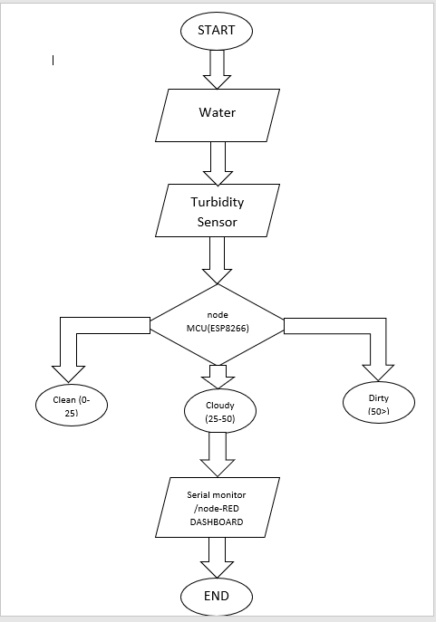

***The above given flowchart is the flowchart of the turbidity sensor which is used to sense the turbidity (quality) of water. This sensor helps to reduce diseases caused by water .***

***Now we are going to describe the flowchart ,what actually the flowchart signify and how the whole process work and provide the result in each possible cases.***

***Step 1:***

***Start the process to check the quality of water using the turbidity sensor which is already designed and programmed.***

***STEP 2:***

***We Will take three sample of water. First which is clean and transparent. Second which is partially clean means cloudy which of not visible clearly or perfectly. And third sample will totally dirty, in which contamination is high.***

***Now, we immerse Turbidity sensor one by one sample water.***

***STEP 3:***

***As we immerse Turbidity sensor in first sample water.***

***. Now immerse the turbidity sensor in the 1st sample of water which is neat and clean , then message is printing on the serial monitor that the water is clean because the turbidity sensor sense the turbidity level lies between 0 to 25.***

***Step 4:***

***Now immerse the turbidity sensor in the 2nd sample of water which is cloudy ,then message is printing on the serial monitor that the water is cloudy because the turbidity sensor sense the turbidity level lies between 25 to 50.***

***Step 5:***

***Now immerse the turbidity sensor in the 3rd sample of water which is dirty, then message is printing on the serial monitor that the water is dirty because the turbidity sensor sense the turbidity level is greater than or equal to 50.***

# *2.3 BLOCK DIGRAM :*

**Display in serial monitor**

**Connect Mqtt server**

**Display in node-RED (debug)**

**Or**

**Node-RED (dashboard)**

**End**

**Node-RED**

**Turbidity sensor**

**Run**

**Nodemcu(esp2866)**

**Arduino IDE**

**Start**

***2.4 List of Hardware Components :***

|  |  |
| --- | --- |
| **SR NO** | **Name of component** |
| 1 | Node MCU |
| 2 | Turbidity module |
| 3 | Turbidity sensor |

1. **Node MCU(ESP8266)**

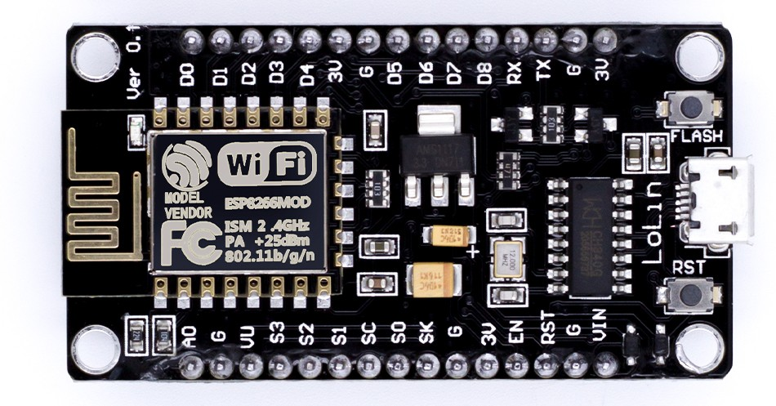

* NodeMCU (ESP8266) is a small and cheap Wi-Fi-enabled microcontroller board.
* It control electronic devices and sensors over the internet.
* Esp8266 is the brain of the board.
* In Esp8266 it has inbuilt wi-fi, so no need for an extra wi-fi adapter.
* It can run small programs written in sketch language.
* The sketch language is the combination of C&C++.
* It used to connect the board throw usb port of your computer.
* There are some GPIO pins(General purpose input/output) this pin are connected to Leds, sensor, motors, etc. They have control them using code.
* In ESP2866 have provide flash memory features. where your code is stored even after you turn off the board.
* Example- you can build cool wi-fi connected projects, like smart home system, weather station, Home automation, etc.

1. **Turbidity module**

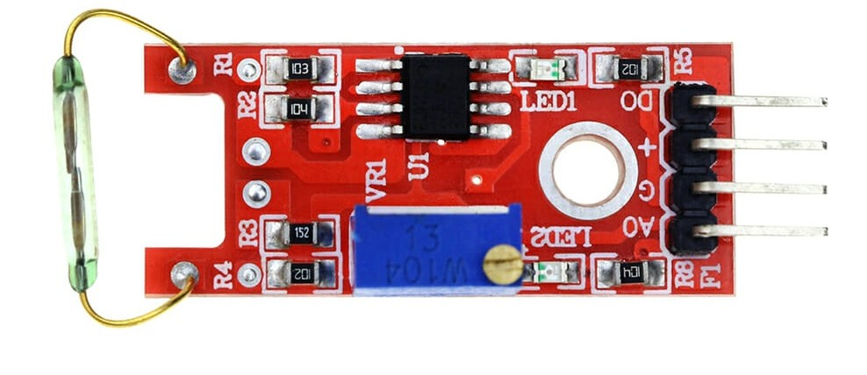

* Turbidity module which is use to connect turbidity sensor to nodeMCU.
* We are not connected to directly turbidity sensor to nodeMCU.

1. **Turbidity Sensor**

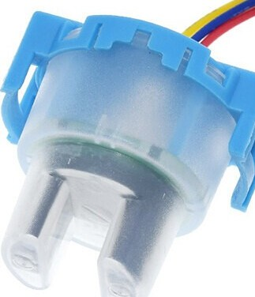

* A turbidity sensor is a device that measures how clear ,cloudy& dirty a liquid is usually water.
* It is used to check the clarity of water or any liquid.
* The sensor works on the principle of how much the light scattered by the particles in the liquid when light shining in the liquid.
* The light source of a led or a laser shine into the water or liquid sample.
* A light detector (usually a photodiode or a light-dependent resistor, LDR) on the sensor detects the amount of scattered light.
* The turbidity sensor measures the intensity of scattered light and converts into a turbidity value.
* The sensor gives the output a voltage or digital signal.
* The turbidity measured the Nephelometric turbidity units(NTU).
* There are some parts of turbidity sensor
  + 1. Light source(LED or Laser)
    2. Photodetector(LDR or photodiode)
    3. Circuitry

**Example**

|  |  |  |
| --- | --- | --- |
| **Water Sample** | **Looks Like** | **Turbidity** |
| Tap Water | Clear | Low |
| River water | Cloudy | Medium |
| Muddy puddle | Dirty | High |

2.5 Schematic Diagram :

Water quality checker

[serial monitor]

[Mqtt server]

[Node-RED dashboard]

hhhjhhgg **Water sampl**sample wate

**Turbidity sensor**

Micro controller

[Node mcu (Esp8266)]

**Water Sample**

# III. RESULTS AND DISCUSSION

|  |  |  |  |
| --- | --- | --- | --- |
| Condition | Turbidity level (in %) | Visibility | Turbidity |
| 1 | 0 < 25 | Clean | Low |
| 2 | 25 < 50 | Cloudy | Medium |
| 3 | >=50 | Dirty | High |

***In this work, the simulation was conducted using Node-RED software. Shows the simulation diagram of the IOT base water quality monitoring system. The simulation demonstrates two modes of operation to the showing result: "Debug" and "Node-RED Dashboard or Serial monitor," each explained in detail. Fig.2 shows the simulation diagram of the IOT base water quality monitoring system.***

* 1. ***Condition 1: Clean***

***This is the 1st condition which specify that the water is clean because the sensor sense the % of turbidity level is lies between 0 to 25.***

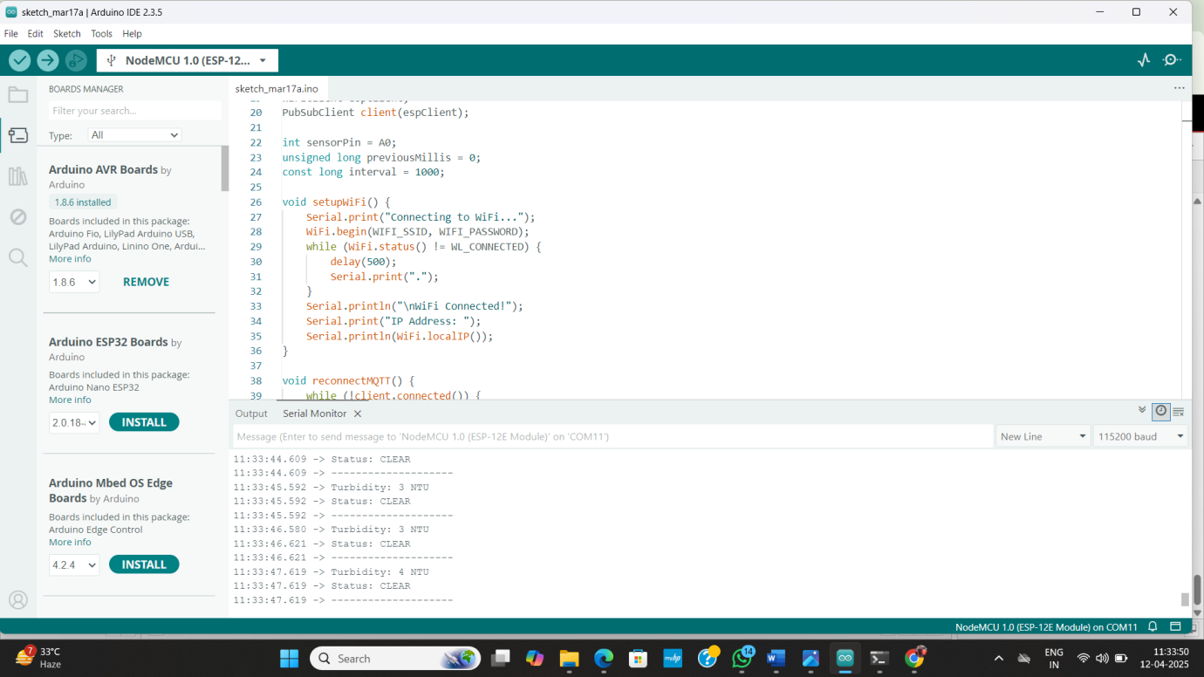

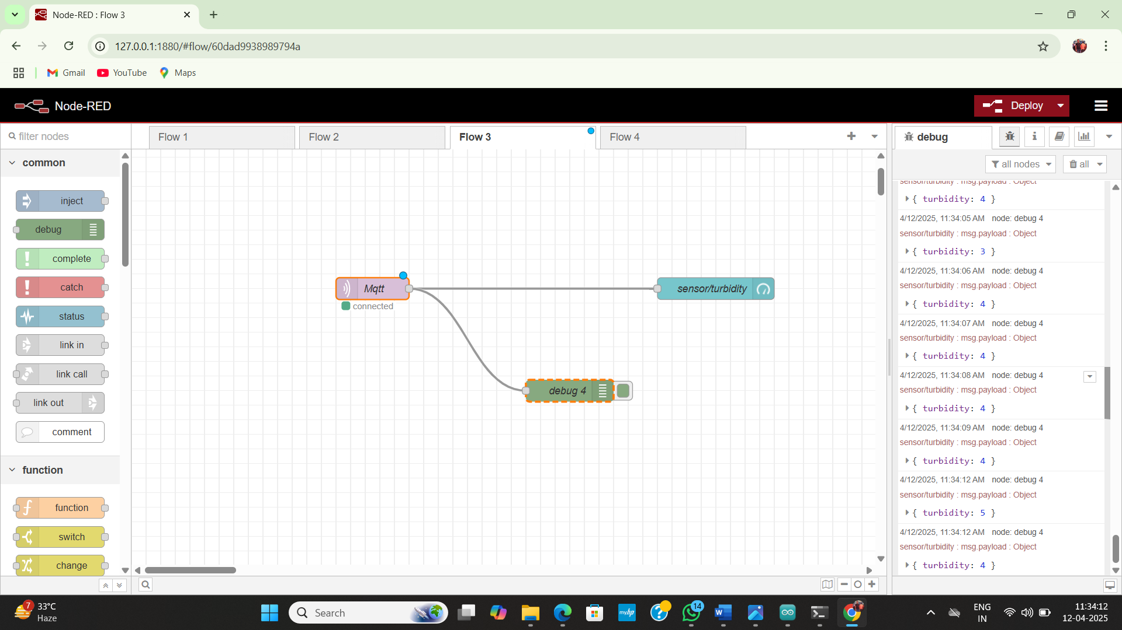

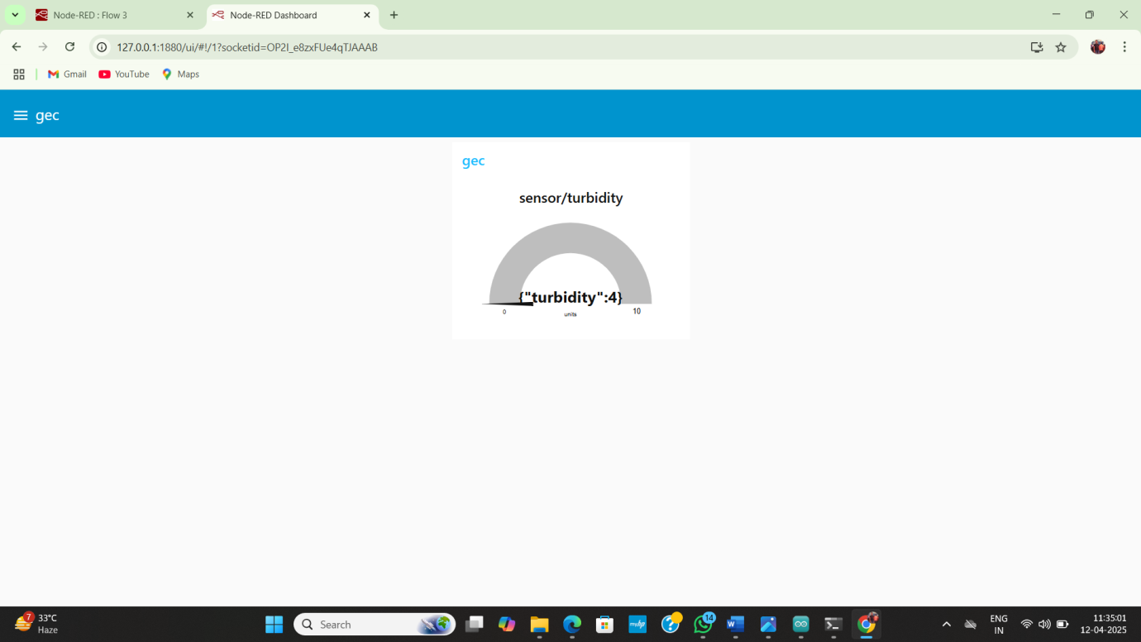

* 1. ***Condition 2 : Cloudy***

***This is the 2nd condition which specify that the water is cloudy because the sensor sense the % of turbidity level is lies between 25 to 50.***

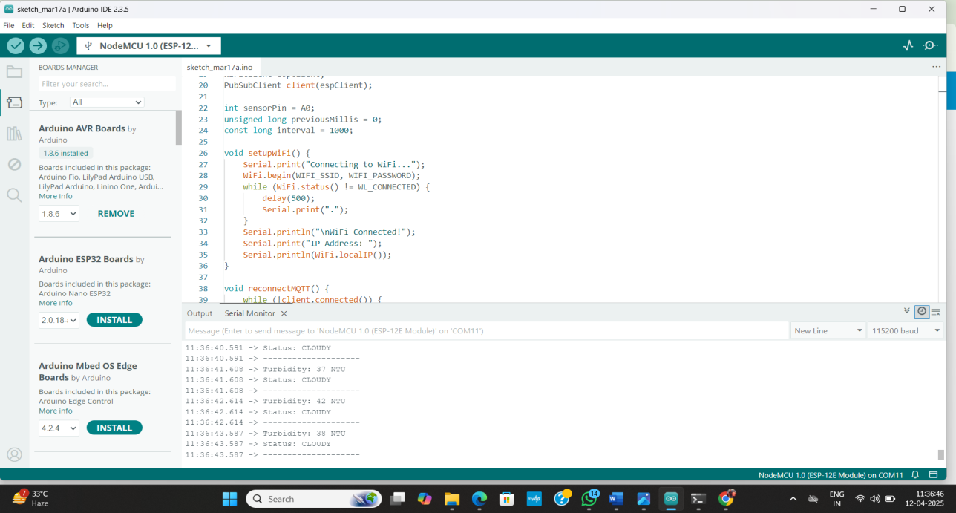

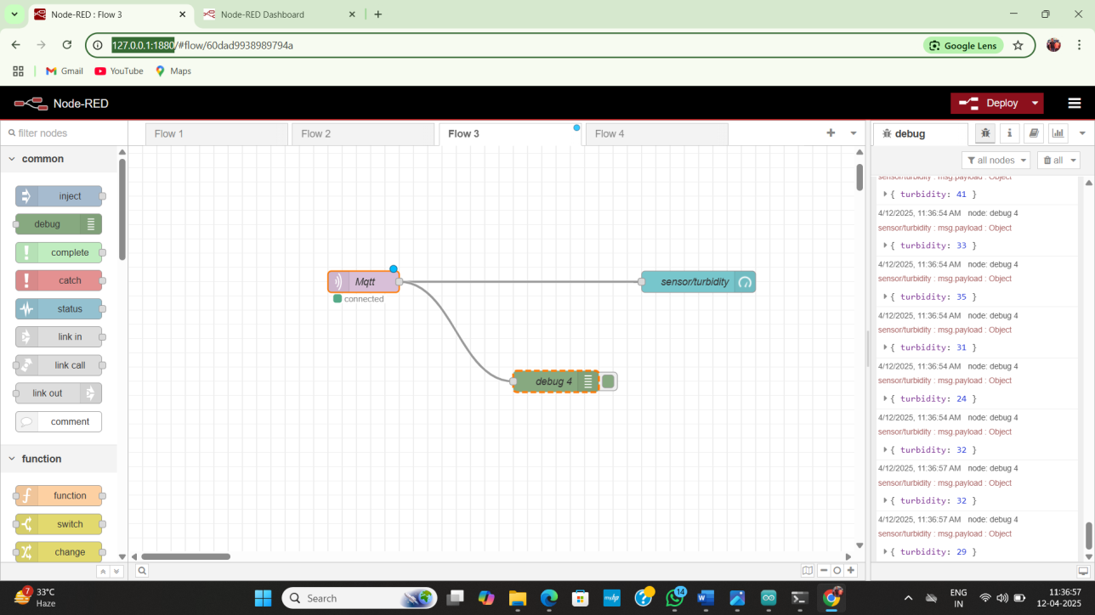

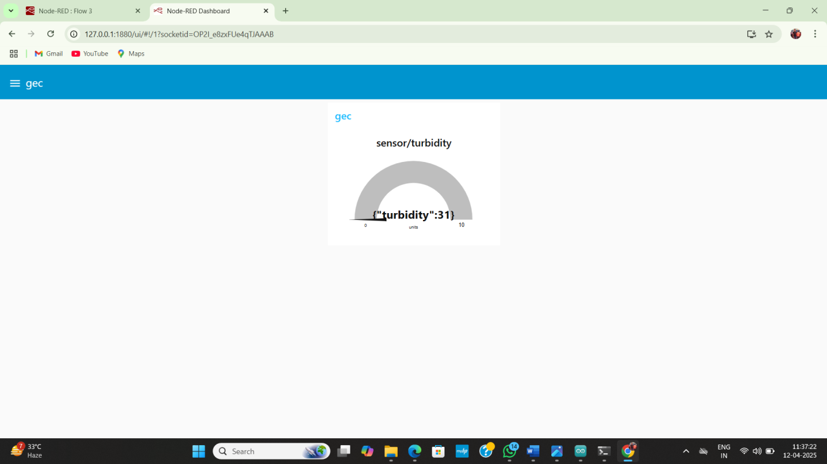

* 1. **Condition 3 : Dirty**

This is the 3rd and the last condition which specify that the water is dirty because the sensor sense the % of turbidity level is greater than or equal to 50.

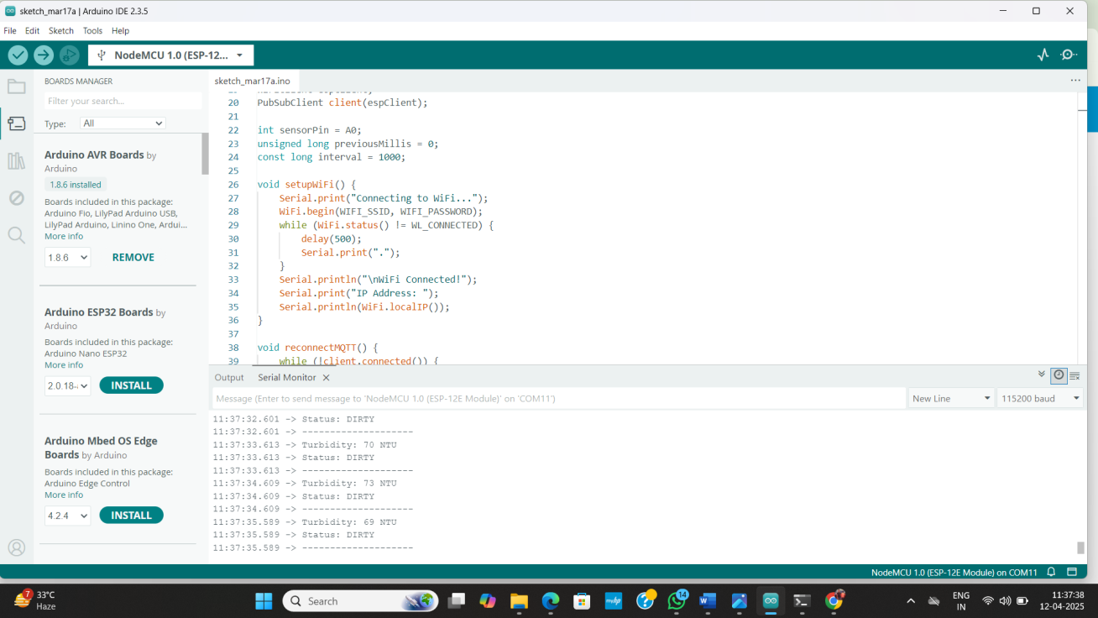

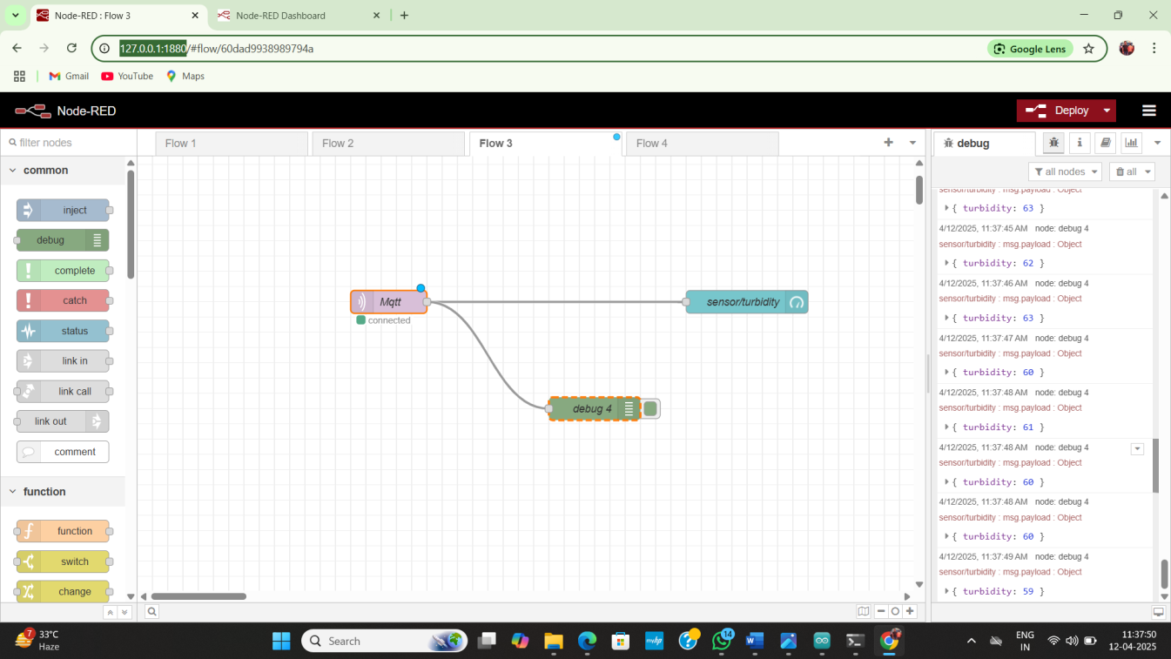

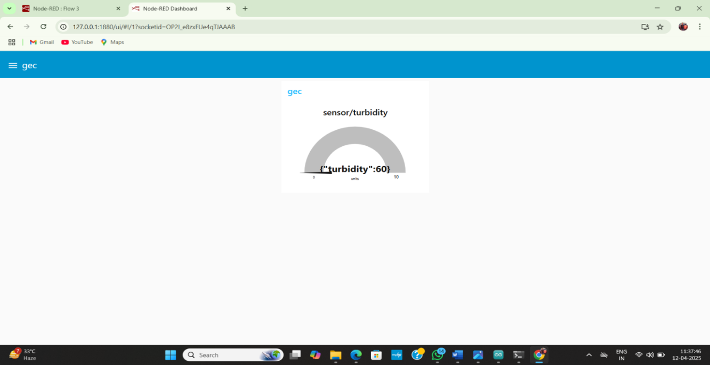

***IV. CONCLUSION***

***This project successfully demonstrated a basic IoT water quality monitoring system using readily available components. By integrating a turbidity sensor, nodeMCU ESP8266, Arduino IDE, and Node-RED, we were able to measure and visualize the relative clarity of water samples. The step-by-step methodology clearly outlined the process, from hardware connection and code implementation to data acquisition and online representation.***

***The Arduino code effectively processed the turbidity sensor readings, categorizing water quality into “clean,” “cloudy,” and “dirty” based on predefined value ranges. The serial monitor provided immediate feedback on the water quality for each sample, confirming the sensor’s ability to differentiate between varying levels of turbidity. Furthermore, the integration of the MQTT broker and Node-RED enabled real-time, online visualization of the water quality data on a dashboard. This crucial step highlights the potential of IoT for remote monitoring and data analysis.***

***The experiment with three distinct water samples effectively validated the system’s functionality. The clear correlation between the visual appearance of the water and the corresponding sensor readings, displayed both on the serial monitor and the Node-RED dashboard, underscores the system’s basic yet functional capability. This foundational work provides a stepping stone for more advanced water quality monitoring systems that could incorporate additional sensors for parameters like pH, temperature, and dissolved oxygen, ultimately contributing to better water resource management and environmental protection. The simplicity and affordability of the components used make this approach accessible for educational purposes and preliminary environmental monitoring applications.***

***V. REFERENCES***

***[1] Monira Mukta, Samia Islam,” IoT based Smart Water Quality Monitoring System “ 2019 IEEE 4th International Conference on Computer and Communication Systems.***

***[2] Vaishnavi V. Daigavane and Dr. M.A Gaikwad,” Water Quality Monitoring System Based on IOT”, Advances in Wireless and Mobile Communications. ISSN 0973-6972 Volume 10, Number 5 (2017), pp. 1107-1116.***

***[3] NITHIN C, NITHIN REDDY, S. GAUTHAM, PAVAN ADITHYA V, PIYUSH KUMAR,” WATER QUALITY MONITORING SYSTEM BASED ON IOT”, 2023 IJNRD | Volume 8, Issue 4 April 2023 | ISSN: 2456-4184 | IJNRD.ORG***

***[4] Varsha Lakshmikantha , Anjitha Hiriyannagowda , Akshay Manjunath , Aruna Patted , Jagadeesh Basavaiah , Audre Arlene Anthony ,” IoT based Smart Water Quality Mon itoring System”, Global Transitions Proceedings (2021)***